**MINI PROJECT – IMPLEMENTATION OF RETIREMENT COMMUNNITY DATABASE**

**AIM:**

To implement retirement community data base management system by means of a Visual Basic Program using forms with ADODC CONTROL .

**ABSTRACT :**

The following program involves Designing forms in Visual Basic which incorporates command buttons , text boxes ,drop down list boxes, radio buttons , check boxes and labels. The forms designed are interlinked with the Microsoft Access files by means of ADODC CONTROL inorder to backup the data.Any modifications will be directly updated onto the data base files . The concept used in this program include

Login form , Registration form , Settings Displayer , Complaint Booker , Service adder and so on so as to satisfy the needs of the Gated Community Data Base Management System.

**SOFTWARE REQUIRED :**

Microsoft Visual Basic 6.0 version

Microsoft Access

**DESCRIPTION:**

RETIREMENT COMMUNITIES is a [residential community](https://en.wikipedia.org/wiki/Residential_community) or [housing complex](https://en.wikipedia.org/wiki/Housing_complex) designed for [older adults](https://en.wikipedia.org/wiki/Old_age) who are generally able to care for themselves; however, assistance from home care agencies is allowed in some communities, and activities and socialization opportunities are often provided.[[1]](https://en.wikipedia.org/wiki/Retirement_community#cite_note-1) Some of the characteristics typically are: the community must be age-restricted or age-qualified,[[2]](https://en.wikipedia.org/wiki/Retirement_community" \l "cite_note-Independent_Living-2) residents must be partially or fully retired,[[3]](https://en.wikipedia.org/wiki/Retirement_community#cite_note-Senior_Living-3) and the community offers shared services or amenities.[2]

This project concentrates on one such Data base management system named “TATHA PATTI” .The main idea of this project is to have a back up data of all the residents.Basically the project has been divided into several modules which concentrates on each and every aspect of data storage and retrieval.

The forms are made interesting with vibrant colours and BIG font size to facilitate the elder people / residents.The forms are connected with the Access files < data base file > by means of an ADODC control .

**MODULES:**

1. HOME PAGE FORM

Coding :

Private Sub Command1\_Click()

Form2.Show

Form1.Hide

End Sub

Private Sub Command2\_Click()

Form3.Show

Form1.Hide

End Sub

Private Sub Command3\_Click()

Unload Me

End Sub

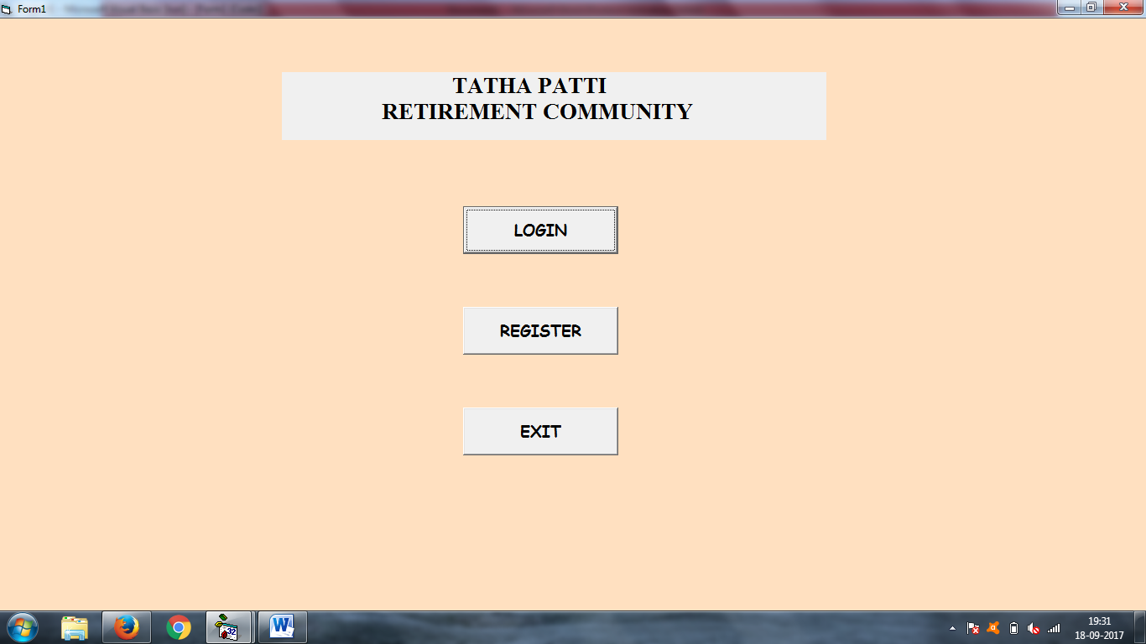

2. LOGIN FORM

Private Sub Command1\_Click()

Dim S As VbMsgBoxResult

If Text3.Text = Text1.Text Then

If Text4.Text = Text2.Text Then

Form4.Show

Form2.Hide

End If ELSE

S = MsgBox("You have entered an inappropriate ID and PASSWORD. ", vbCritical + vbOKOnly, "WRONG ")

End If

End Sub

Private Sub Command2\_Click()

Form1.Show

Form2.Hide

End Sub

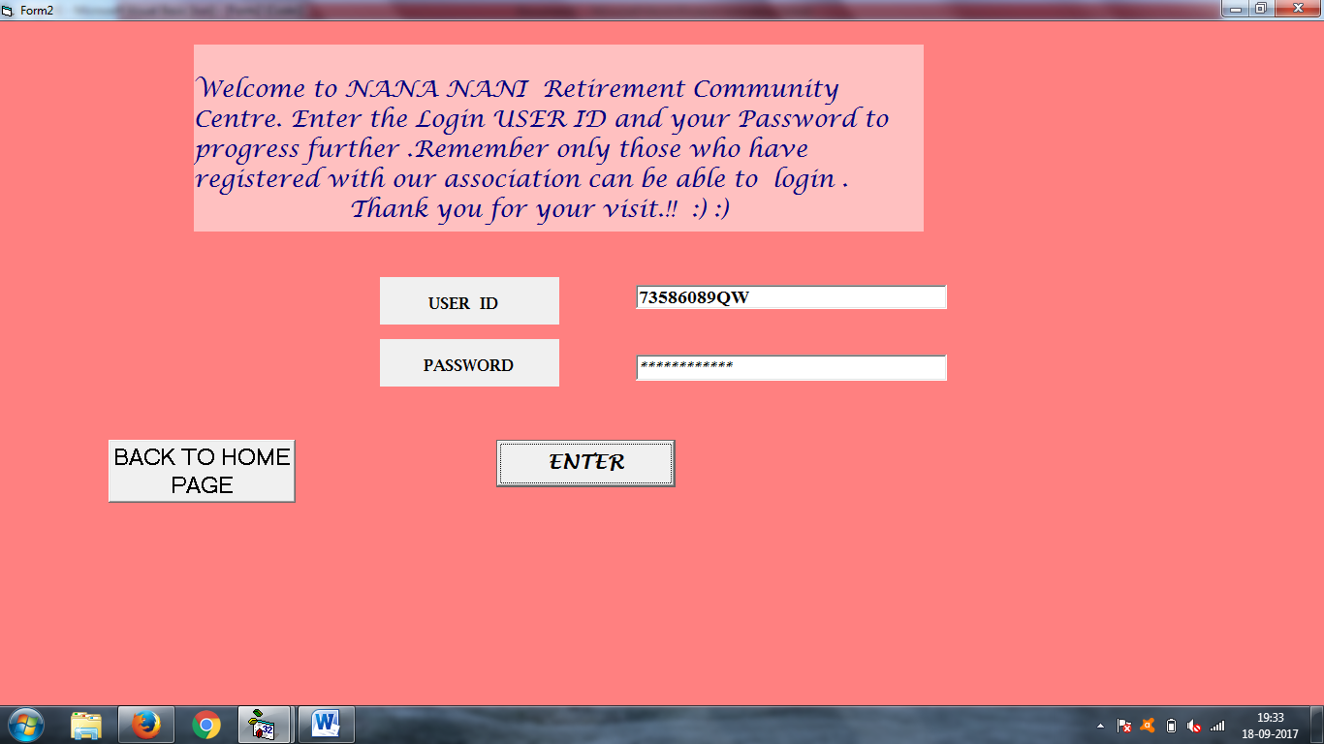

3. REGISTRATION FORM

Private Sub Command1\_Click()

Form8.Show

Form3.Hide

End Sub

Private Sub Command2\_Click()

Form1.Show

Form3.Hide

End Sub

Private Sub Command5\_Click()

Adodc1.Recordset.MoveNext

Adodc1.Recordset.Update

Adodc1.Recordset.Update

Dim F As VbMsgBoxResult

F = MsgBox("YOU HAVE BEEN SUCCESSFULLY REGISTERED. THANK YOU FOR REGISTERING.", vbOKOnly + vbInformation, "REGISTRATION")

End Sub

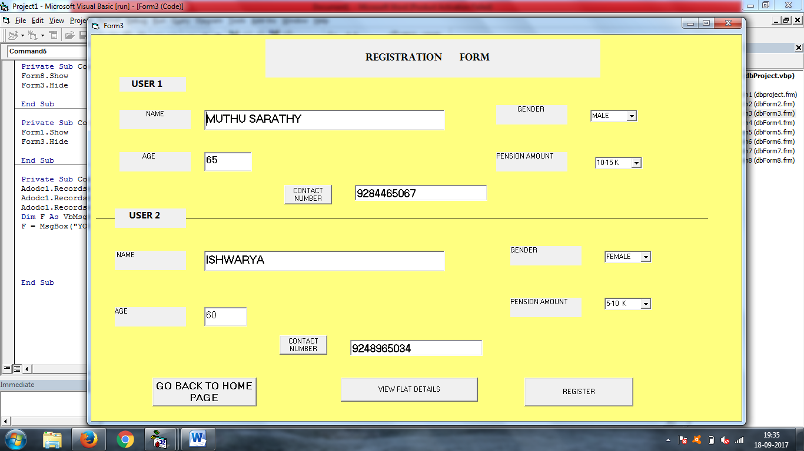

4. VIEWING FLAT DETAILS AND PREBOOKING FORM

Private Sub Command1\_Click()

Form6.Show

Form4.Hide

End Sub

Private Sub Command2\_Click()

Form5.Show

Form4.Hide

End Sub

Private Sub Command3\_Click()

Form7.Show

Form4.Hide

End Sub

Private Sub Command4\_Click()

Form1.Show

Form4.Hide

End Sub

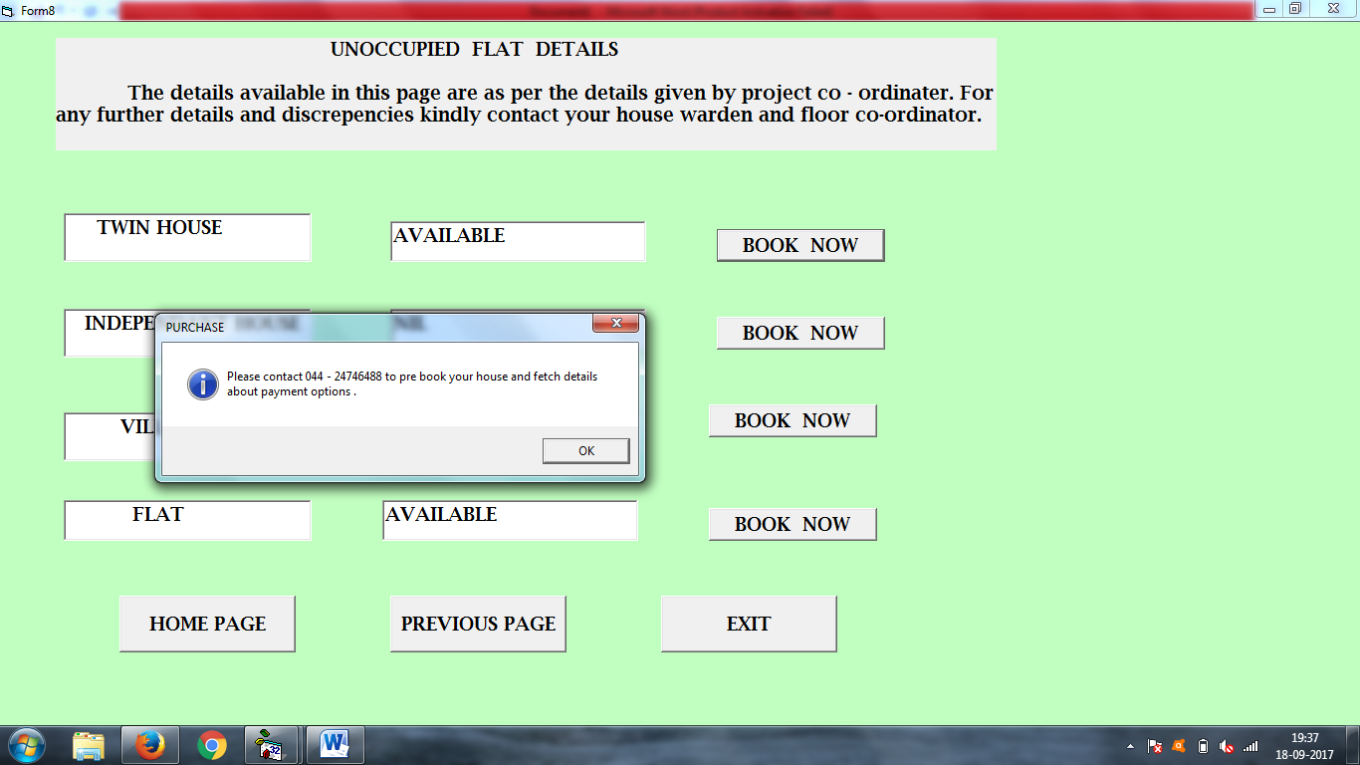

5. VIEWING SETTINGS FORM

Private Sub Command1\_Click()Form4.ShowForm5.Hide

End Sub

Private Sub Command2\_Click()

Form1.Show

Form5.Hide

End Sub

Private Sub Command3\_Click()

Unload Me

End Sub

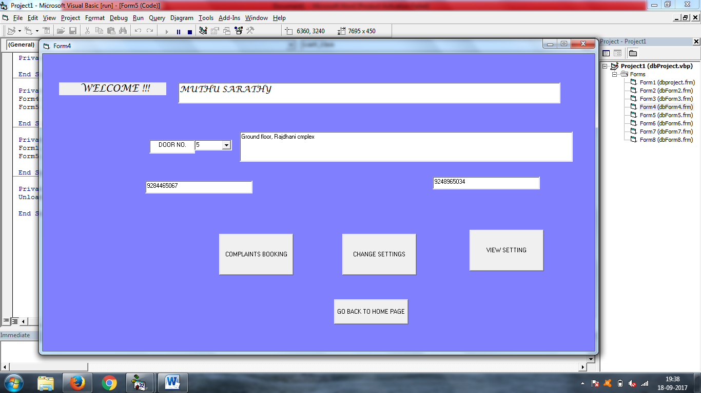

6. VIEW SETTINGS FORM

Private Sub Command1\_Click()

Form4.Show

Form5.Hide

End Sub

Private Sub Command2\_Click()

Form1.Show

Form5.Hide

End Sub

Private Sub Command3\_Click()

Unload Me

End Sub

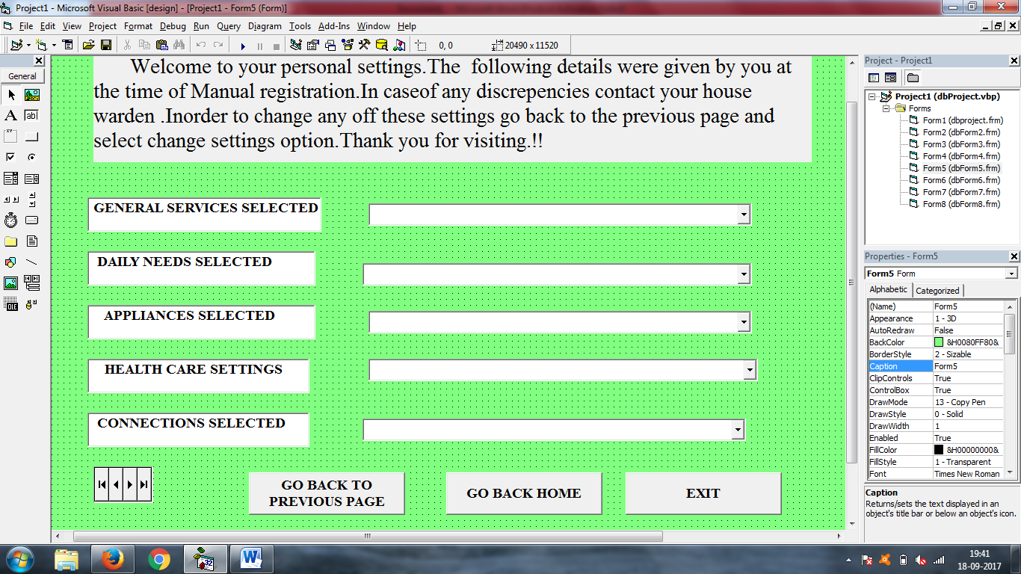

7. COMPLAINT BOOKING FORM

Private Sub Command1\_Click()

Form4.Show

Form6.Hide

End Sub

Private Sub Command2\_Click()

Form1.Show

Form6.Hide

End Sub

Private Sub Command3\_Click()

Unload Me

End Sub

Private Sub Command4\_Click()

Dim res As VbMsgBoxResult

res = MsgBox("your complaint has been registered." & Chr(10) & "The co-ordinator will contact you soon.", vbInformation + vbOKOnly, "complaint ")

Form6.Show

End Sub

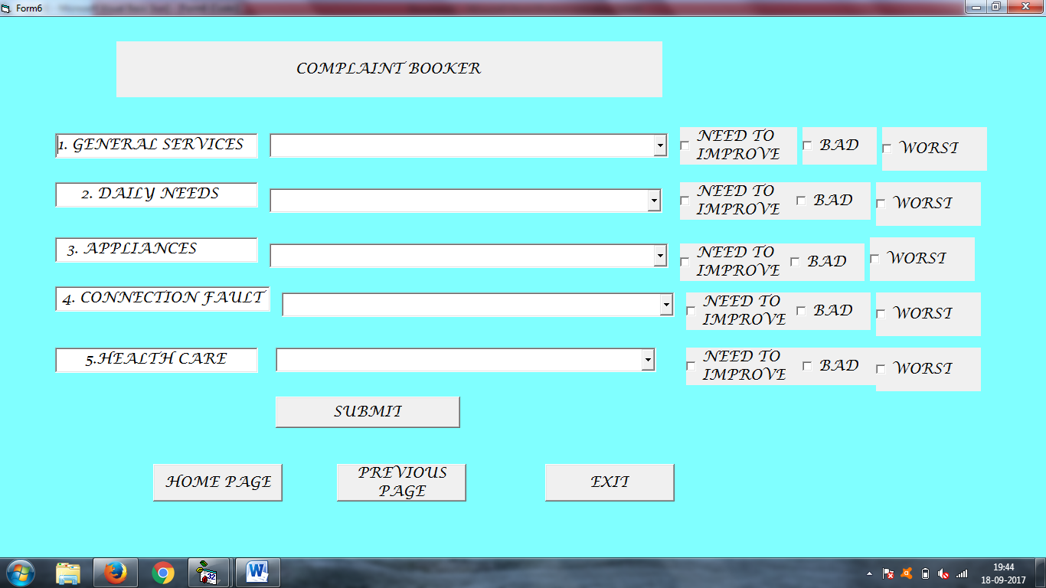

8. UPDATING SERVICES FORM

Private Sub Command1\_Click()

Dim TOT As VbMsgBoxResult

Dim T As VbMsgBoxResult

TOT = MsgBox("Your changes have been notified.are you sure ? ", vbOKCancel + vbExclamation, "warning")

If TOT = vbOK Then

T = MsgBox("YOUR CHANGES ARE UPDATED.", vbInformation + vbOKOnly, "NOTIFY")

Else

Form7.Show

End If

End Sub

Private Sub Command2\_Click()

Form1.Show

Form7.Hide

End Sub

Private Sub Command3\_Click()

Form4.Show

Form7.Hide

End Sub

